Online Energy Utility Platform

Dan Tudor

Group 30443

The objective of this project is to create a web application for a energy utility platform. The users will have separate accounts which can be either admin account or client account. Also there are multiple devices on the platform and each one is linked to a client.

The user has the option to create an admin account or a client account. The admin user can perform multiple actions such as: create/read/update/delete other users of both types, create/read/update/delete devices and also link devices to clients.

1. **Conceptual architecture**

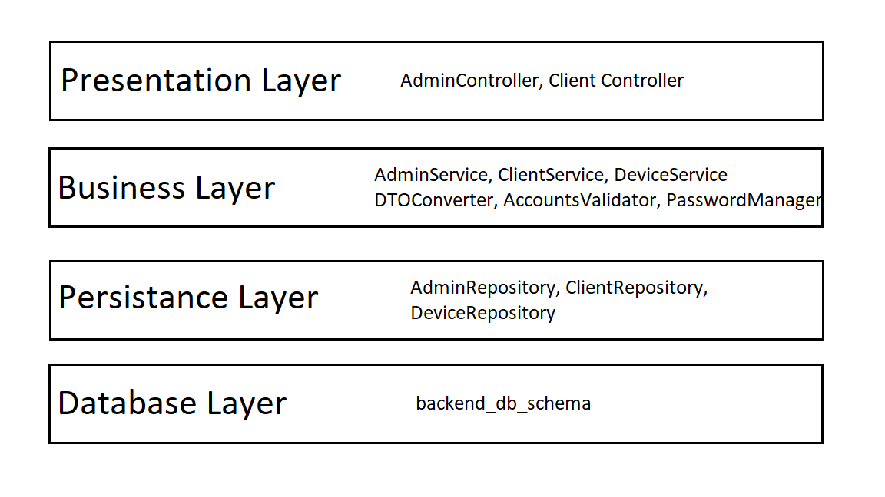

Create/read/update/delete new users

Create/read/update/delete new devices

Link devices with clients

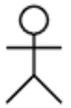

1. **Database**

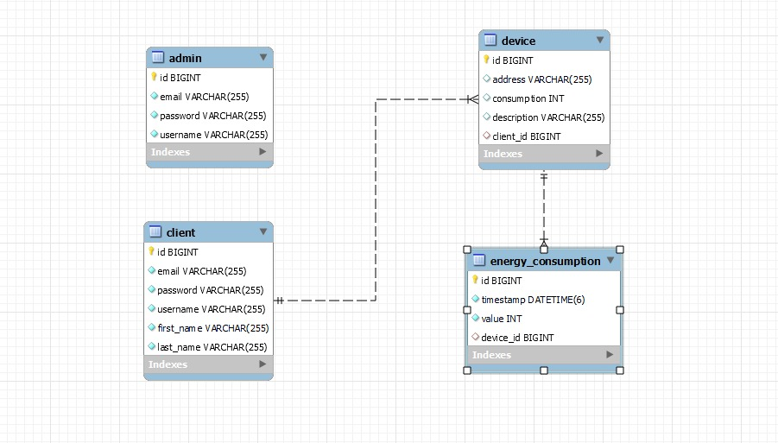

The tables inside the database have to following links:

-each client can have multiple devices

-each device belongs to only one client

-each device can have multiple energy consumptions

-each energy consumption belongs to only one device

1. **Deploy**

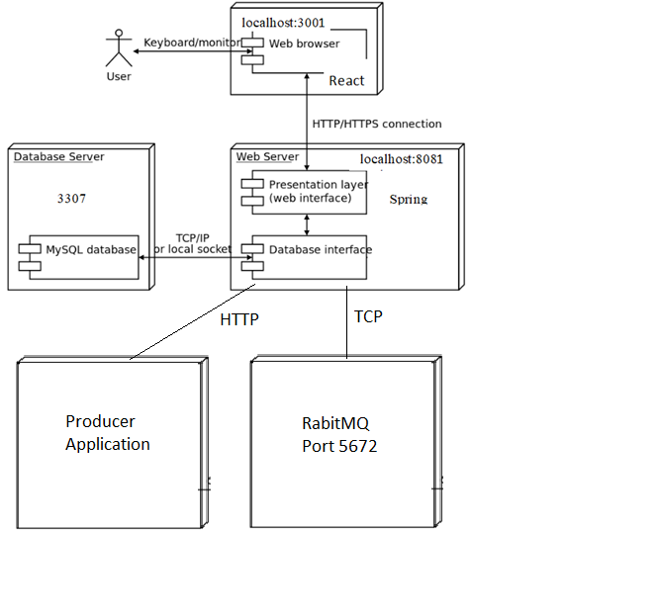

1. **Architecture**

Receive

Send

…

Sensor

Sensor

Sensor

RabbitMQ

Queue

Message Consumer

Database

Backend

Frontend Web Application